Registration Form
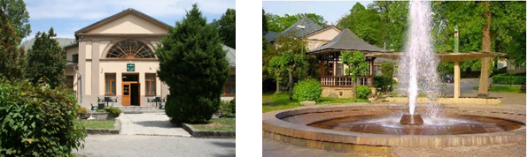
Application ☐ paper with participation in the conference
☐ paper without participation

Participant’s affiliation
Kliknite alebo ťuknite sem a zadajte text.

Participant’s name and surname
Kliknite alebo ťuknite sem a zadajte text.

Contact address:
- phone / fax - e-mail
Kliknite alebo ťuknite sem a zadajte text. Kliknite alebo ťuknite sem a zadajte text.

- street / zip / city
Kliknite alebo ťuknite sem a zadajte text.

Identification number of the institution (IČO, DIČ, BIN, TAX-ID, VATIN)
Kliknite alebo ťuknite sem a zadajte text.

Paper title in English
Kliknite alebo ťuknite sem a zadajte text.

Key words
Kliknite alebo ťuknite sem a zadajte text.

Co-authors
Kliknite alebo ťuknite sem a zadajte text.

Accommodation
☐ 06.09. – 07.09. 2023
☐ 07.09. – 08.09. 2023

This document should be submitted by June 30th, 2023 to e-mail protechma@tuke.sk
Underline (mark) suitable
The preliminary abstract should be attached as a separate file (abstract_temp.doc)

Note: By registering, you agree that all information provided by you can be used by the Organizing Committee. The Organizing Committee reserves the right to use any photograph/video taken at the PROTECHMA 2023 Conference, without the expressed written permission of those included within the photograph/video.

